

1. **The first page when the user or company will open our site.**

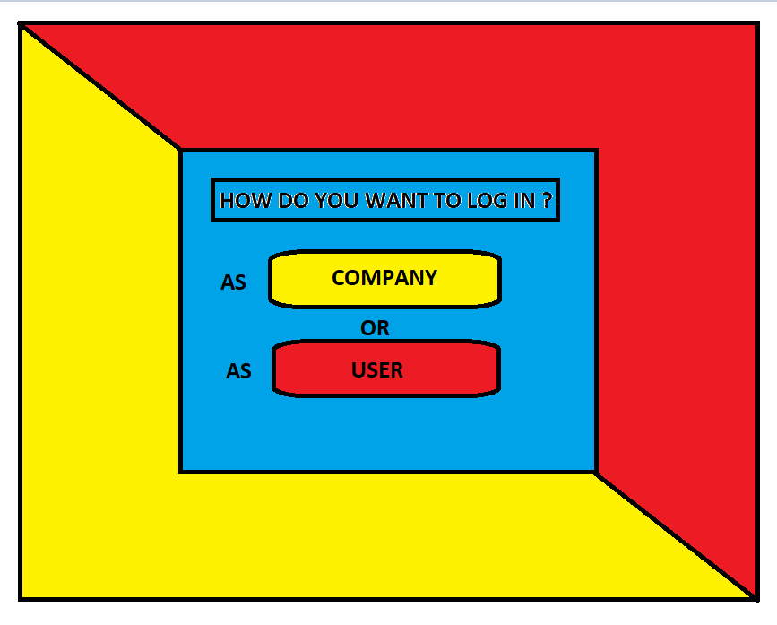

1. **Here is the second page where the user & company have to select their options.**

**The company will get the id and password from us so the user can not login as the company.**

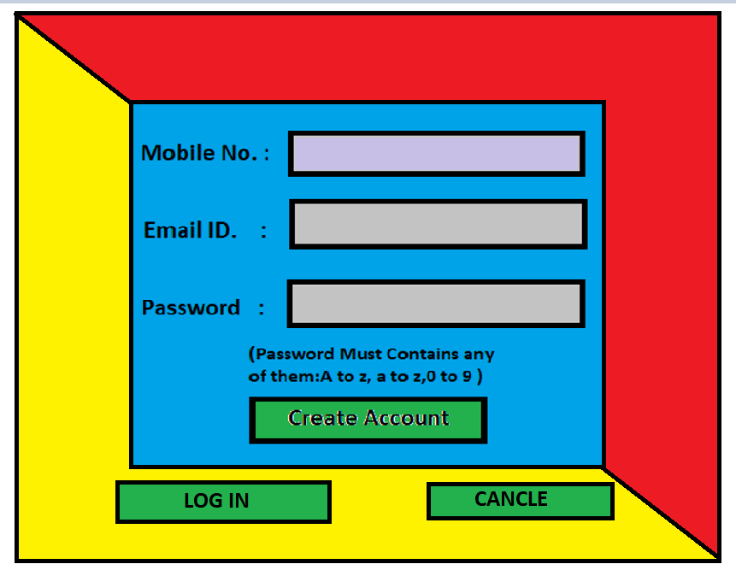

1. **This is the login page of the User. Where the user will sign up in the website using the mobile and email id.**

**Or he can login if he/she have account already.**

**Or if someone don’t want to login then he can click on cancel. But that user may not able to user some particular feature of the site like they cannot give review …etc.**

1. 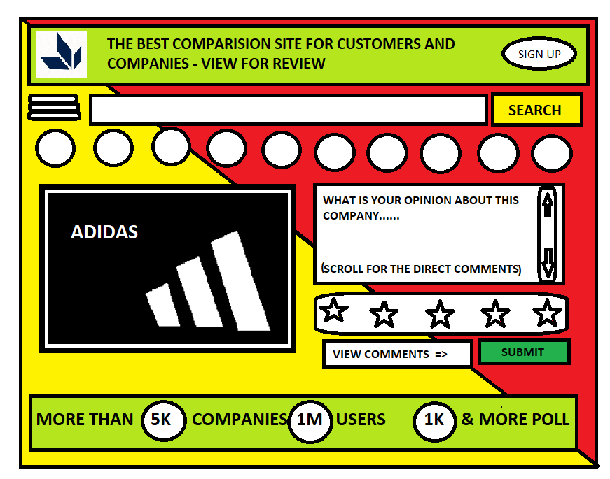**this is the main page of the user where they can see the polls and many more other features of the site.**

**Like : searching the company, polls and other things in search bar**

**Category selection in the rounded options**

**Use the 3 dot option for more facilities**

**The unsigned up user can also signup without reopening the site at the corner of the site.**

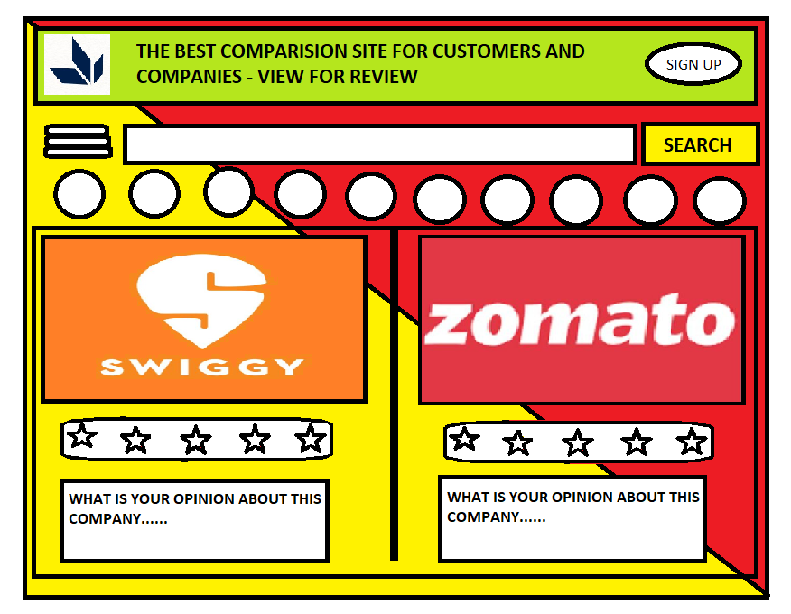

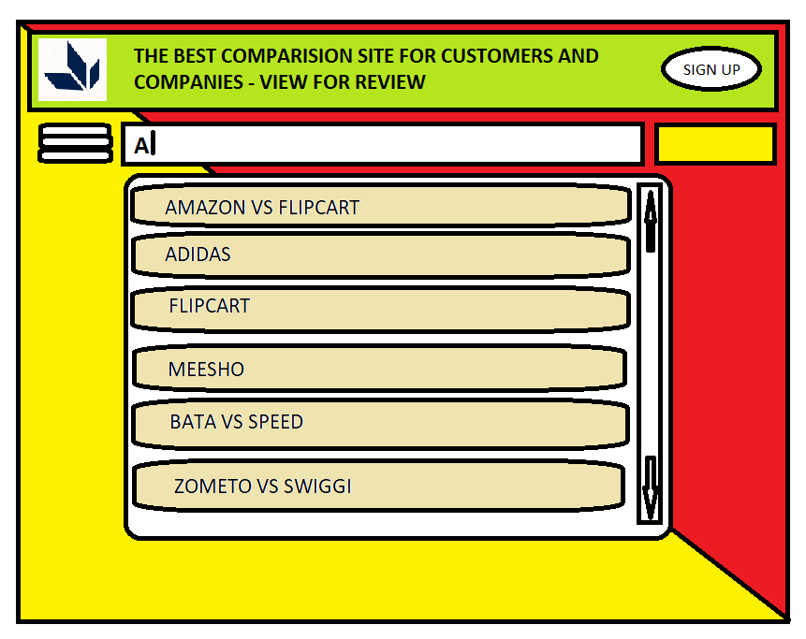

1. **This is the search bar where the user can search the poll or company for details.**

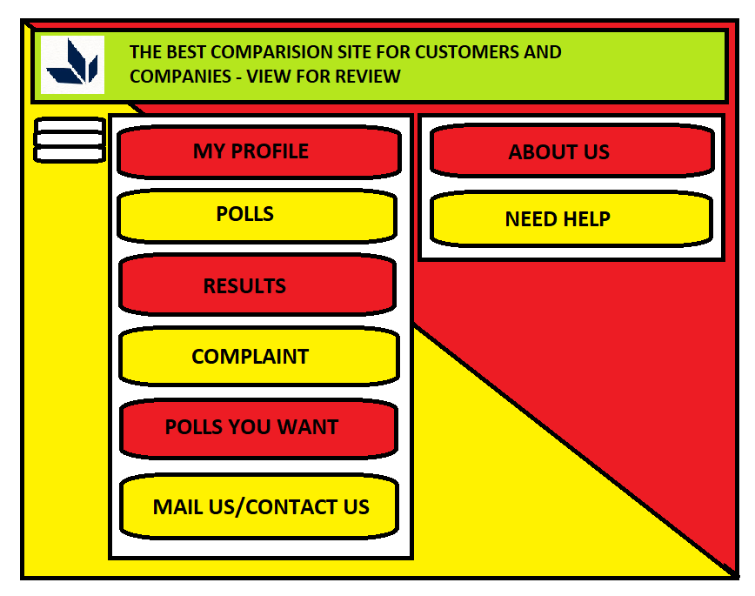

1. **This is the 3 dot option of the user page where multiple options are given.**

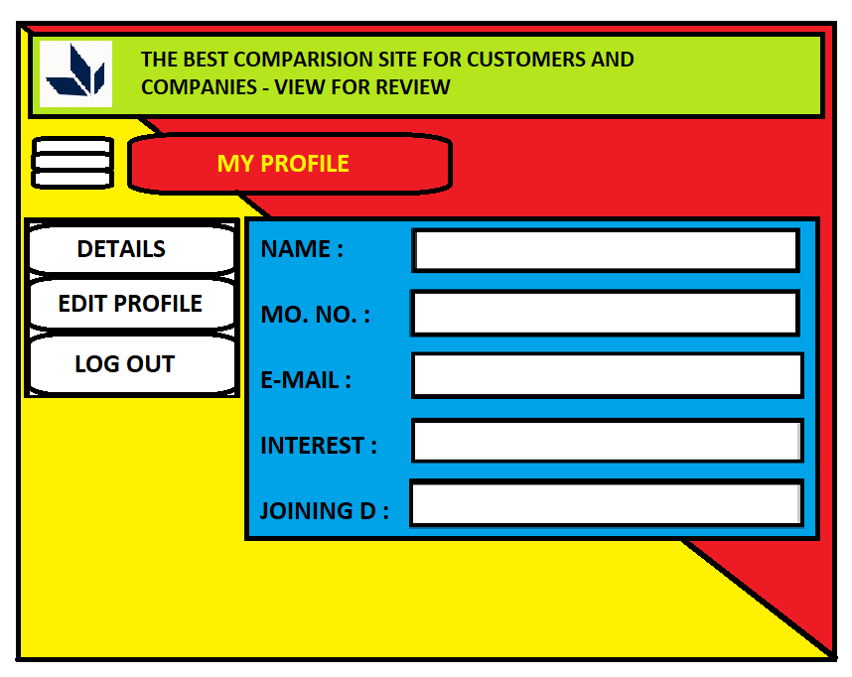

1. **This is the first option of 3 dots : profile**

**When the user will login then his profile will created automatically where the user’s detail will be shown.**

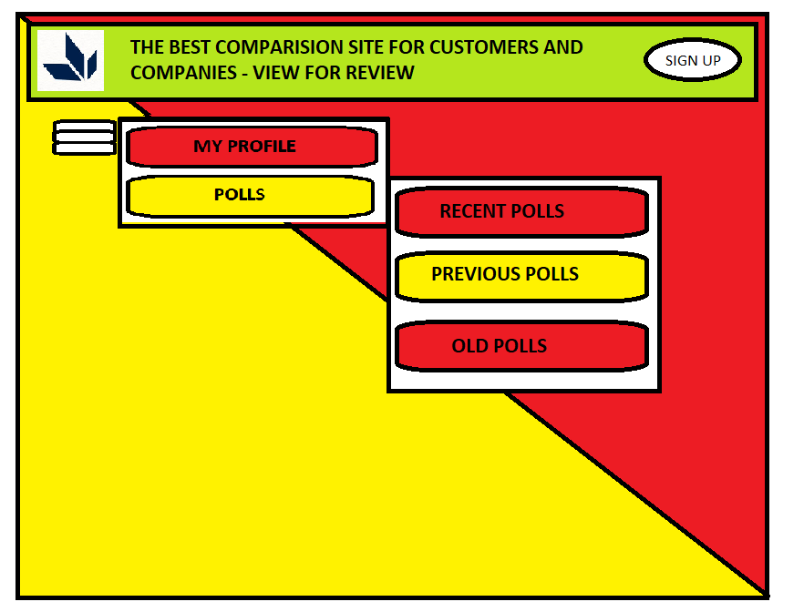

1. **The second option is for polls where the 3 option will be provided 1 is for recent polls ( current polls) 2 is for previous poll (the polls before 10-15 days) 3 is for old polls (expired polls)**

**And here also the search bar will provided after selecting the option**

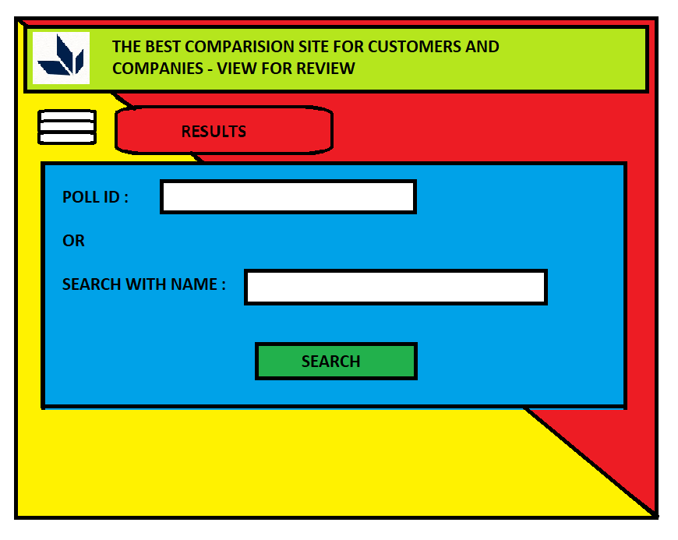

1. **This is the 3rd option for searching the result of the poll.**

**Where the user can add the poll id or can search with the name of that company**

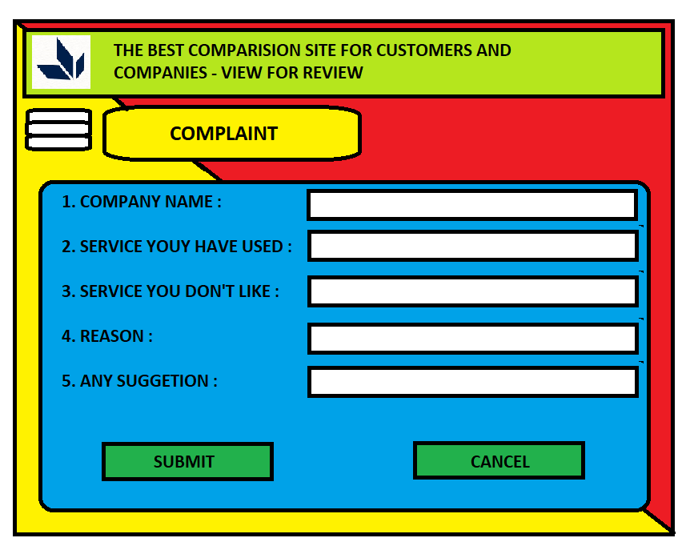

1. **This is the 4th option where the user can complaint about the company about the service or any type of problem with the company’s product like damaged product delivered or any other type of complaint.**

**The user can also give the suggestion to the company about their products.**

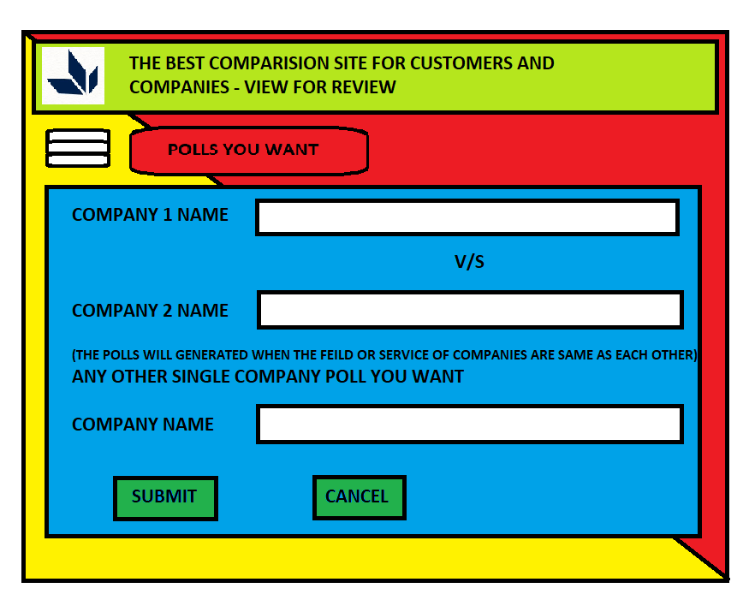

1. **This is the option for suggesting the upcoming polls what the user want so then we(website) can contact with that company and generate the poll.**

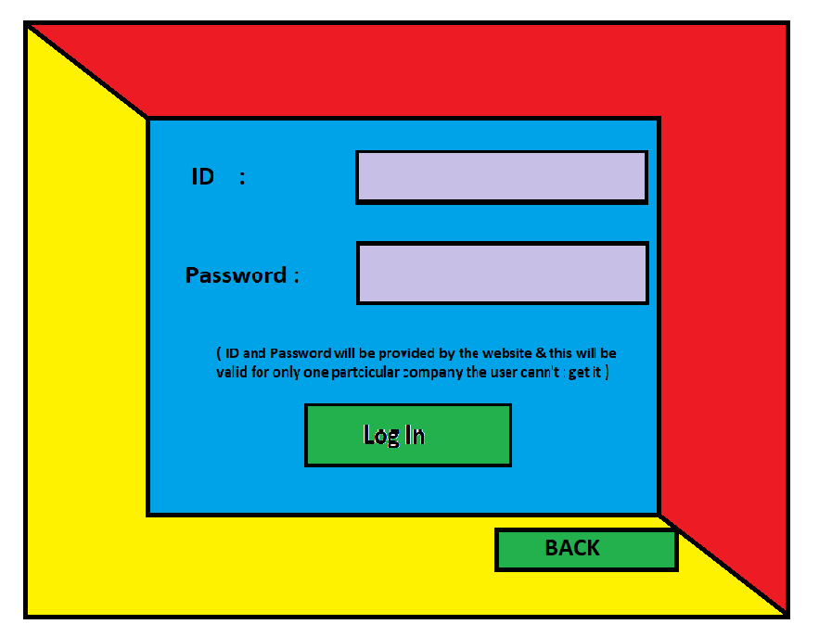

1. **This is the login page of the company where the company will get the id and password from us(site).**

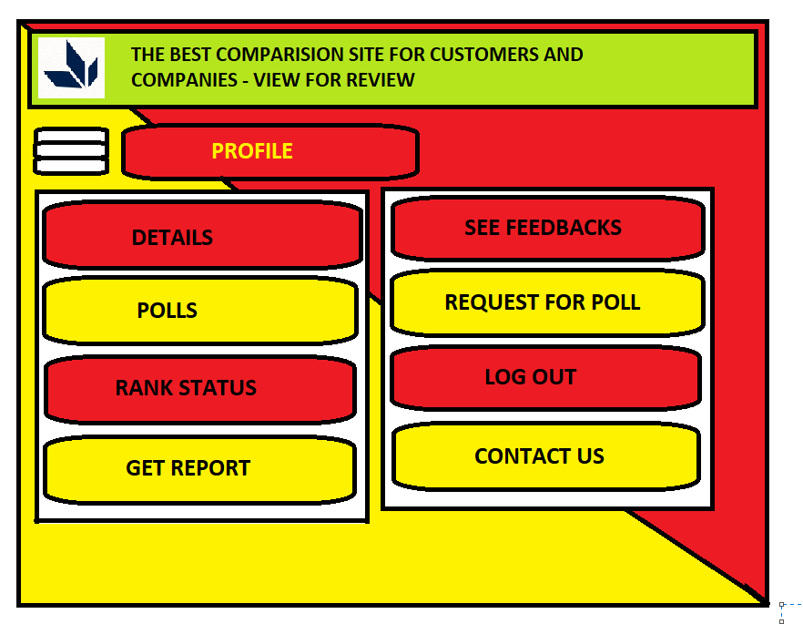

1. **This is the main page of the company where the company can access many options.**

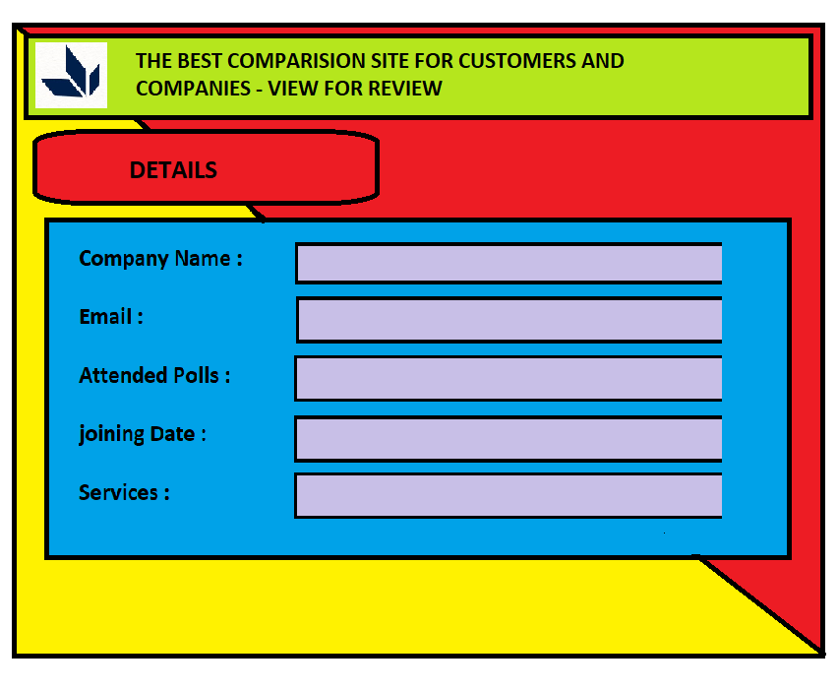

1. **This is the details page of company where the company see the detail about his self.**